3. Visualization of the rotten tomatoes rating for the top 20 films from Pixar.

Description:
The dataset for the visualization was taken from https://www.kaggle.com/datasets. The data was then visualized using various techniques in python. The result is a graphical representation of the rotten tomatoes rating for the top-grossing Pixar movies.

Importing required libraries:
For this visualization, we will be using the matplotlib library to plot the graph, we use Pandas and NumPy for data preprocessing. We start by using the import keyword to import the required libraries (as mentioned above).
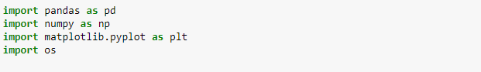

Data preprocessing:
In this step, the dataset is cleaned to remove the noisy data and make the required changes to the data formats.
Before doing, the pre-processing, we need to import the dataset by using the read_csv () function. We import the CSV file as a new data frame named df.
After importing the data frame, it is important to check if there are any empty or missing values in the data frame. To do this, we use the isnull () function which returns Boolean values.

This will return True if there is a null or missing value and False otherwise.
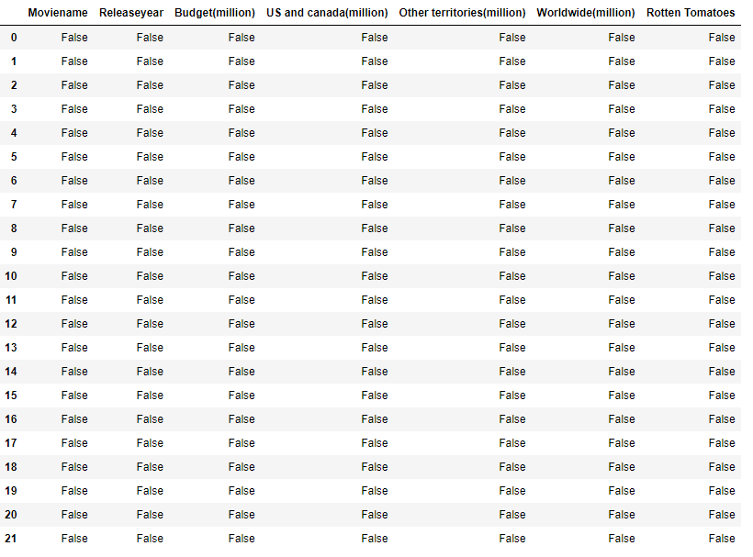
As we can see from the above, the data frame does not contain any missing or empty values. The next step is to check the data types of the columns, this can be done using the types command.
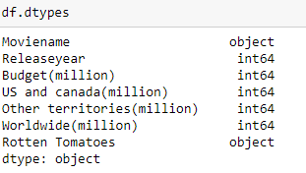
We can see that the Rotten Tomatoes column has data of the type object(string) whereas it is an integer value. The next step would be to convert it to integer datatype. For converting the data type into an integer, we need to remove the % from the column, so it can be converted to int type. To achieve this, we use the .str.replace () function.
After replacing the % symbol we can convert the data type into integer using the astype () function.
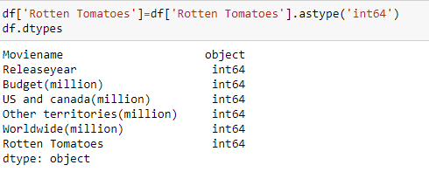

Plotting:
The final step in the process is to plot a graphical representation of the data. I choose the Bar graph representation to represent the above data.
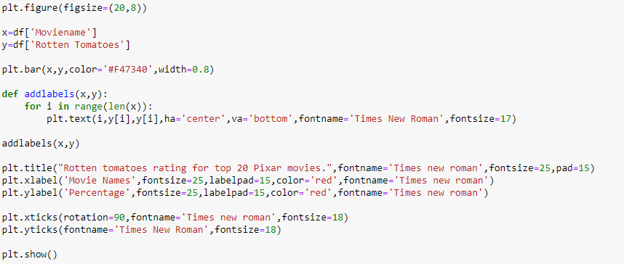

Output:
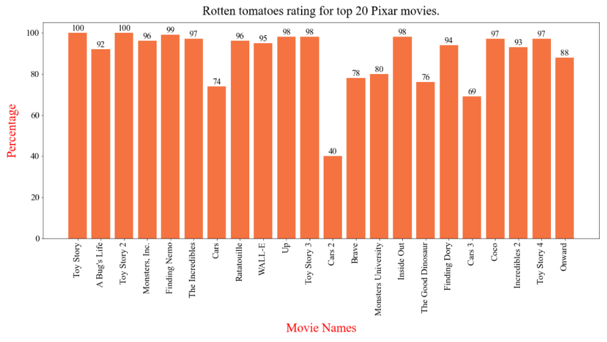
I wanted the output to look a little better, so I used photoshop to add a few elements.

Final Output:

